MFE FORMWORK MR11 SYSTEM
Deployment Guide
Version 1.0
Prepared for
MFE Formwork
Prepared by
MyIntellX project team
Date
21 October 2026
Status
Draft for client review

Document control
Item | Detail
Document | Deployment Guide
System | MFE Formwork MR11 System, version 1.0
Document version | 1.0
Date | 21 October 2026
Status | Draft for client review
Based on | Repository izzatmyintellx05/MFE, branch main, commit 0cc8c36
Prepared for | MFE Formwork
Prepared by | MyIntellX project team
Intended readers | Client IT
Classification | Confidential, for client and vendor use only

Revision history
Version | Date | Description | Author
1.0 | 21 October 2026 | First issue for client review | MyIntellX project team

Contents
1. Introduction 4
2. Environments 4
3. What you need before you start 4
4. Environment variables 4
5. Setting up the database in Supabase 5
6. Deploying to Vercel (recommended) 6
7. Deploying to Azure (alternative) 6
7.1 Using the deployment script 6
7.2 Using Docker 6
7.3 Using Azure DevOps 6
8. Running it on your own machine 6
9. Checking the deployment 6
10. Go-live checklist 7
11. Updates and rolling back 7
12. Build and maintenance commands 8
Appendix A: Screenshots 9

1. Introduction
This guide walks the client's IT team through installing the MR11 System and keeping it up to date. We recommend hosting it on Vercel in the Singapore region, with a Supabase PostgreSQL database in ap-southeast-1. Azure App Service is a supported alternative.
A first deployment takes about an hour, and most of that time goes into creating the accounts and the database. Once it is running, the checks in section 9 confirm that everything works.

2. Environments
Environment | Hosting | Database | What it is for
Local demonstration | npm run dev on a laptop | None; it runs in memory and loads the sample workbooks from uploads/ | Demonstrations only, because data is lost when it stops
Local with a database | npm run dev | A local PostgreSQL on port 5433 (npm run db:start) | Development and testing
Staging | A Vercel preview deployment | A separate Supabase project | User acceptance testing and trying out changes
Production (recommended) | Vercel, region sin1 | Supabase PostgreSQL, through the transaction pooler | Live use
Production (alternative) | Azure App Service (Linux, Node 22) or Docker | Supabase PostgreSQL | When the client prefers Azure

3. What you need before you start
- Node.js 22 and npm. Keep the repository's .npmrc file, which contains legacy-peer-deps=true.
- Access to the Git repository.
- A Supabase account for the production database.
- A Vercel account linked to the repository, or an Azure subscription with the Azure CLI installed.
- Optionally, PostgreSQL 18 on your own machine, and Docker.

4. Environment variables
Variable | Required? | Example or default | What it does
DATABASE_URL | Yes, in production | postgresql://postgres.<ref>:<password>@aws-0-ap-southeast-1.pooler.supabase.com:6543/postgres?pgbouncer=true | Connects to Supabase. DATABASE_POSTGRES_URL or POSTGRES_URL work too. Without it, the system runs in memory only
JWT_SECRET | Yes | A random string of at least 32 characters | Signs session tokens. Changing it signs everyone out. If it is not set, the code falls back to a default that is published in the repository, so never let that happen in production
NODE_ENV | Yes, in production | production | Makes the server serve the built frontend
PORT | No | 3000 | The port used by npm start and Docker
USD_TO_MYR_RATE | No | 4.20 | A fallback exchange rate, used only if no exchange-rate service can be reached
STORAGE_DIR | No | uploads_storage | The folder for stored files (local and Azure)
WEB_DIR | No | public | The folder holding the built frontend for the API server
DISABLE_HMR | No | true | Turns off live reload during development

Put the real values in Vercel (Settings, then Environment Variables) or in Azure (Configuration, then Application settings). On your own machine, use a .env file, which Git ignores. You can generate a good secret with openssl rand -hex 32.

5. Setting up the database in Supabase
- Create a Supabase project in the ap-southeast-1 (Singapore) region, with a strong database password.
- Open SQL Editor and choose New query. Paste in the whole of supabase/schema.sql and run it. This creates the tables and adds the nine roles, the seven departments, the administrator and eight demo accounts.
- Go to Project Settings, then Database, and copy the Transaction pooler connection string (port 6543). This is your DATABASE_URL.
- After you first sign in, change the administrator password straight away, and either delete the demo accounts or give each one a new password.
Please note that npm run db:seed only fills the in-memory store and does not write anything to Supabase, so use supabase/schema.sql instead.

6. Deploying to Vercel (recommended)
- In Vercel, choose Add New, then Project, and import the repository.
- Leave the build settings as they are. vercel.json already sets the build command (npm run build), the output folder (dist), the sin1 region and the API routing.
- Add DATABASE_URL, JWT_SECRET and NODE_ENV=production for Production. If you use preview deployments, add them for Preview too, pointing at the staging database.
- Deploy. The build produces the frontend in dist/ and the API bundle in api/index.js.
- Run the checks in section 9.
From then on, every change that reaches main is deployed automatically.

7. Deploying to Azure (alternative)

7.1 Using the deployment script
Set DATABASE_URL, then run ./deploy-azure.sh. The script signs in to Azure, creates the resource group rg-mfe-formwork-prod, a Linux B1 App Service plan and a Node 22 web app, sets the application settings (including a random JWT_SECRET), and deploys a zip of the build. Before you run it, change LOCATION: the script uses eastus by default, and southeastasia is much closer to Malaysia.

7.2 Using Docker
docker build -t mfe-mr11 .
docker run -p 3000:3000 -e DATABASE_URL="<supabase url>" -e JWT_SECRET="<secret>" mfe-mr11

7.3 Using Azure DevOps
azure-pipelines.yml builds the project whenever main or azure-deploy changes, and deploys only from azure-deploy. Before using it, replace the JWT_SECRET that is written in the file with a secret pipeline variable, and add DATABASE_URL to the application settings.

8. Running it on your own machine
git clone https://github.com/izzatmyintellx05/MFE.git
cd MFE
npm install
npm run dev
Then open http://localhost:3000. If DATABASE_URL is not set, the system loads the sample workbooks in uploads/ and keeps everything in memory.

9. Checking the deployment
Check | How to do it | What you should see
The application is running | Open https://<host>/health | {"status":"ok"}
The database is connected | Open https://<host>/api/health/db | "status":"CONNECTED" and a list of tables
Signing in works | Sign in as the administrator | The MR11 page opens
Uploading rebuilds the MR11 | Upload the BD workbook on the Business Development page | A success message, and the BD rows appear in the MR11
Market data is coming through | Open the MR11 page | The exchange-rate and LME cards show today's values and their sources
Export works | Click Export on the MR11 page | An .xlsx file downloads
Each environment has its own secret | Sign in on production, then try the same token on staging | Staging rejects the production token

See Figure 1 in Appendix A: The sign-in page you should see at https://<host>/ once the deployment is running.
See Figure 2 in Appendix A: After the BD workbook is uploaded, the MR11 lists its rows and the market cards show live values.

10. Go-live checklist
☐ The production JWT_SECRET is a random value, different from staging's
☐ DATABASE_URL points at the production Supabase project
☐ The administrator password has been changed, and the demo accounts removed or given new passwords
☐ The repository has been made private
☐ /api/health/db has been restricted or removed, and CORS limited to the production domain
☐ The custom domain and its HTTPS certificate are working
☐ Backups are confirmed on the Supabase plan
☐ Every department's latest workbook has been uploaded
☐ All the checks in section 9 pass

11. Updates and rolling back
Task | On Vercel | On Azure
Releasing a new version | Merge into main | Run the pipeline from azure-deploy, or run the script again
Rolling back | Open Deployments, pick the last good one and choose Promote to Production | Redeploy the previous build package
Changing a setting | Edit the variable, then redeploy | Edit the application settings, and the app restarts by itself

Rolling back the application does not change the database. Changes to the database are rare in this system, but always take a backup before making one.

12. Build and maintenance commands
Command | What it does
npm run dev | Starts the development server on port 3000
npm run build | Builds the production frontend (dist/) and the serverless API bundle (api/index.js)
npm start | Runs the server, in production mode when NODE_ENV=production and dist/ exists
npm run lint | Runs the TypeScript type check
npm run db:start, db:stop and db:status | Control a local PostgreSQL on port 5433
npm run test:persistence | Builds the project, then runs the end-to-end persistence test against a local database

Appendix A: Screenshots
These screenshots were taken from version 1.0 running with the sample workbooks, so the projects and figures in them are examples rather than live data.
Figure | What it shows | Mentioned in
Figure 1 | The sign-in page you should see at https://<host>/ once the deployment is running | 9. Checking the deployment
Figure 2 | After the BD workbook is uploaded, the MR11 lists its rows and the market cards show live values | 9. Checking the deployment

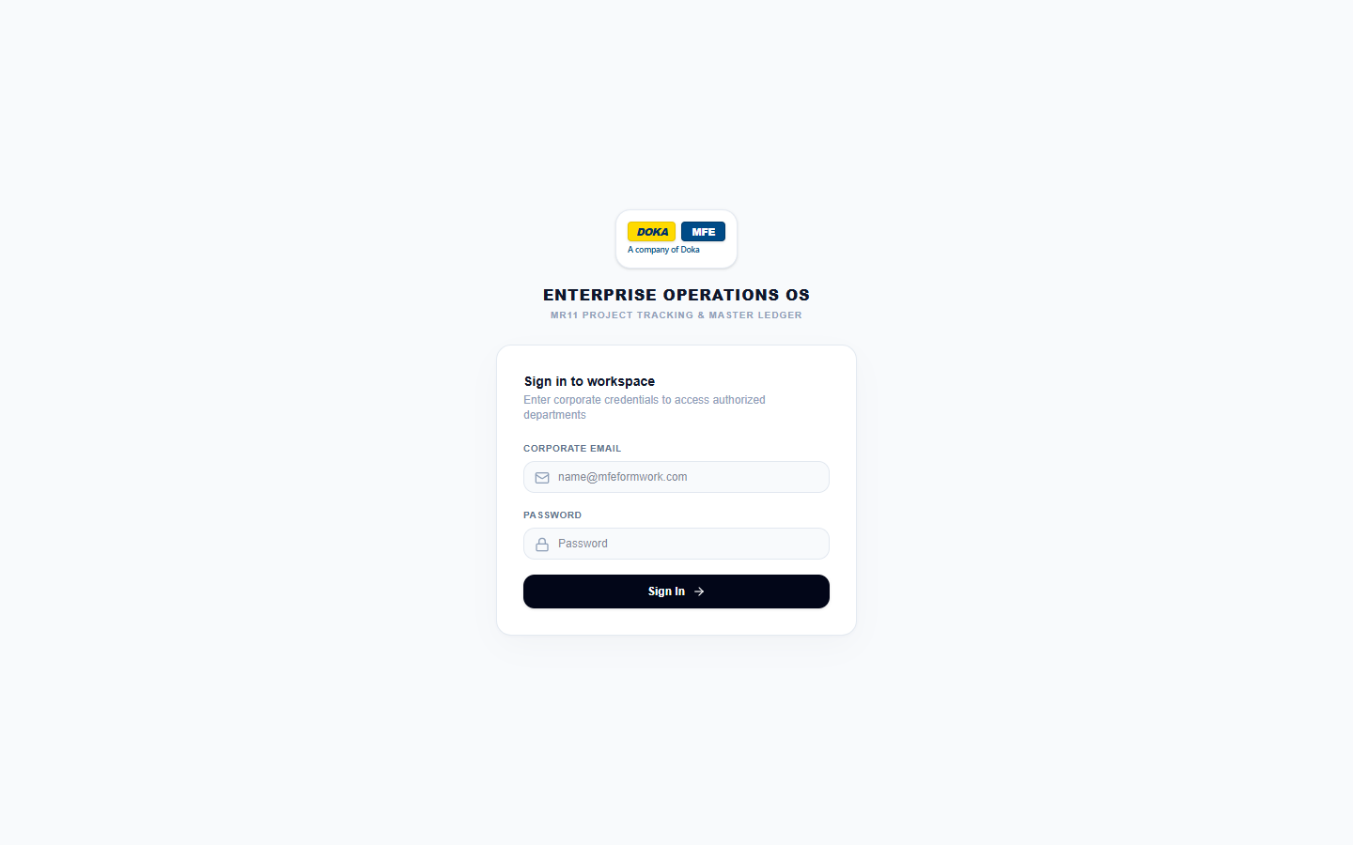
Figure 1: The sign-in page you should see at https://<host>/ once the deployment is running
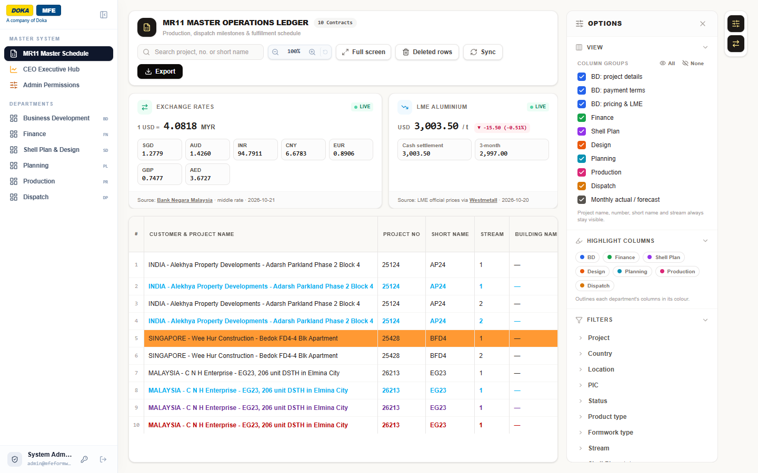
Figure 2: After the BD workbook is uploaded, the MR11 lists its rows and the market cards show live values

